

**TAITA TAVETA UNIVERSITY.**

**SCHOOL OF SCIENCE AND INFORMATICS.**

**DEPARTMENT OF INFORMATICS AND COMPUTING. BACHELOR OF SCIENCE IN INFORMATION TECHNOLOGY.**

**RESEARCH PROJECT**

**TITLE: CENTRALIZED PATIENTS’ DATA INFORMTION SYSTEM.**

**A research project Submitted in Partial Fulfilment of the Requirements of the Bachelor of Science in information technology and Technology**

***15th February, 2022.***

# Group name and members

1. **ANDREW KIBIWOTT TU01-IC211-0383/2017**
2. **SHABRACK ONYANGO JAMES TU01-IC211-0328/2017**
3. **BRIAN OMWENGA TU01-IC211-0334/2017**

# PREFACE

In the preparation of this project of a centralized hospital management system, we have precisely demarcated all the important points. We have made my best possible efforts to remove all the errors. It is a great pleasure for us to thank all those valuable suggestions that have been given to us. We must thank the almighty for this inspiration and guidance as well as our parents, lecturers who directed us to complete this research project.

# ACKNOWLEDGEMENT

We thank God, the Almighty, for his showers of blessings throughout our research work to complete the research successfully. We would like to express our deep and sincere gratitude to our research supervisor, DR SOLOMON MWANJELE, for giving me the opportunity to do research and providing invaluable guidance throughout this research. His sincerity and motivation have deeply inspired us. He has taught us the methodology to carry out the research and to present the research works as clearly as possible. It was a great privilege and honor to work and study under his guidance. We are extremely grateful for what he has offered us. We are extremely grateful to our parents and our parents for their love, prayers, caring and sacrifices for educating and preparing us for our future and continuing support to complete this research work.

# DECLARATION

We hereby declare that the attached research project is our own work, and that no part of it has been copied or someone’s work. We understand that penalties for submitting work which is not my own, or distributing our work to other students, may be severe, up to and including failing the degree.

**Student declaration**

Student name………………………………………………………………

Registration no……………………………………………………….

Signature…………………………………………. Date……………………………

**Student declaration**

Student name………………………………………………………………

Registration no……………………………………………………….

Signature…………………………………………. Date……………………………

**Student declaration**

Student name………………………………………………………………

Registration no……………………………………………………….

Signature…………………………………………. Date……………………………

**Student declaration**

Student name………………………………………………………………

Registration no……………………………………………………….

Signature…………………………………………. Date……………………………

# TABLE OF CONTENTS

Contents

1

**TAITA TAVETA UNIVERSITY.** 1

Group name and members 2

PREFACE 3

ACKNOWLEDGEMENT 4

DECLARATION 5

TABLE OF CONTENTS 7

Table of figures 10

image 1 logical design of the system 10

image 2 graphical illustration of the system 10

image 3 use case diagram of the system 10

image 4 Scheduling implementation plan 10

image 5 Testing plan 10

image 6 cost Scheduling plan 10

image 7 Log in page 10

image 8 The Dashboard: 10

image 9 Patient form: 10

image 10 Complaint form: 10

image 11 Sections dropdown: 10

image 12 Adding and deleting administrators 10

image 13 Adding new users and granting sectional access 10

image 14 General graphical report 10

image 15 Blood test reports 10

image 16 Sputum tests reports 10

image 17 Rehabilitation reports 10

image 18 Maternity patients report 10

image 19 Dental patients report 10

image 20 Xray population reports 10

CHAPTER ONE: INTRODUCTION. 11

1.1. Background Information 11

1.2. Problem Statement 11

1.3. Main Objective 12

1.3.1. Other Objectives 12

1.4. Rationale of the Study 12

1.5. Research Questions 13

1.6. Scope of the Study 13

1.7. Significance of the Study 13

CHAPTER TWO: LITERATURE REVIEW. 15

2.1 Literature review. 15

2.2 Function of existing electronic health record systems. 17

2.3 Components of existing electronic health record systems. 17

2.4 Characteristic/features of existing electronic health record systems. 18

➢ patient’s Registration 18

2.5 Types of existing electronic health record systems. 18

2.6 Challenges of existing electronic health record systems 19

CHAPTER THREE: RESEARCH METHODOLOGY AND DESIGN. 20

3.1 Introduction 20

3.2 Research Design 20

3.3. Study Location 21

3.4. Study Population. 21

3.5 Research Approach and strategy. 21

3.6 Sampling Techniques. 21

3.7 Data Collection Methods 22

3.8 Development tools and materials. 22

CHAPTER FOUR: SYSTEM ANALYSIS 24

4.0 Overview 24

4.1 Feasibility study 24

4.2 Description of the current systems 25

CHAPTER FIVE: SYSTEM DESIGN 26

5.0 Overview 26

5.1 Description of the proposed systems 26

5.2 Functional requirements of the proposed systems 26

5.2.1 Interface requirements 26

5.2.2 Security requirements 27

5.2.3 Business requirements 27

5.2.4 Compliance requirements 27

5.3 Non-functional requirements of the proposed system 27

5.4 Logical design of proposed system 27

Logical design 27

5.5 Physical design of proposed system 28

29

29

29

29

29

29

Testing and implementation plan 32

Testing plan 33

Updating the cost 34

Cost schedule 34

Benefits 34

Conversion dates 34

System constraints 34

CHAPTER SIX: SYSTEM IMPLEMENTATION 35

6.0 Overview 35

6.1 System testing- integration, unit 35

6.2 System changeover 36

6.3 Documentation –internal and external documentation 37

CHAPTER SEVEN: CONCLUSION AND RECOMMENDATION 38

7.0 Achievement 38

7.1 Challenges 38

7.2 Proposed Centralized Patient and Health Record Management System limitation 38

7.3 Recommendation 38

7.4 Conclusion 39

Chapter 8:Appendix 40

External manual 40

allows user to record patients complaints 42

Internal manual 43

Reports 44

Graphical reports from departments 44

Sample questionnaire 48

References 50

# Table of figures

image 1 logical design of the system 27

image 2 graphical illustration of the system 28

image 3 use case diagram of the system 29

image 4 Scheduling implementation plan 31

image 5 Testing plan 32

image 6 cost Scheduling plan 33

image 7 Log in page 39

image 8 The Dashboard: 40

image 9 Patient form: 41

image 10 Complaint form: 41

image 11 Sections dropdown: 42

image 12 Adding and deleting administrators 42

image 13 Adding new users and granting sectional access 43

image 14 General graphical report 43

image 15 Blood test reports 44

image 16 Sputum tests reports 45

image 17 Rehabilitation reports 45

image 18 Maternity patients report 45

image 19 Dental patients report 46

image 20 Xray population reports 46

# CHAPTER ONE: INTRODUCTION.

## 1.1. Background Information

Ensuring that patients receive quality medical care services has been a concern in our country, Kenya. In response to reports research, media focus on the poor quality of our country’s health care system, managers are under pressure to ensure that they provide quality health care services. Health care managers and medical practitioners believe that actions would be taken but under resource constraints, they are not sure on how to go about it.

## 1.2. Problem Statement

In the present, third world states, such as Kenya, are in progress to migrate from the manual paper-based systems with digital automated medical information systems

The mid-term review of KHSSP 2014-2018 showed drastic difficulties and gaps in the National Health Information System which warrant immediate solutions (MTR, 2017). The release showed that while steps forward have been achieved in upgrading the quality of data, level of analysis and use. Kenya was still experiencing setback in keeping up better resourcing, integration and unified working among medical sectors. This is important as it reduces redundancies of data in HIS/M&E and provide good use of the available resources in providing better health information systems (MTR, 2017).

The Government of Kenya is set to upgrade access to the quality health care services and to ensure that the health sector achieves its mandate in the achievement of Vision 2030 and attainment of the Sustainable Development Goals (SDGs). To achieve this set goal, the Ministry of Health developed the Kenya Health Policy (2014–2030). A revised policy aims is to plan, design and implement a communications technology (ICT) infrastructure, and health information systems (HIS) for the management and provision of essential health care

A number of separate data collection information systems exist in which data for the health sector is held in different databases. The systems currently are mostly not interoperable, often stored in different formats across various systems and locations thus bringing up numerous redundancies in data, setting resources and time loss in data collection and management. Weak reporting from non-state facilities (NGO/FBOs and private stakeholders), sharing data among multiple information systems (IS), usability remains a major in the attainment of computerized IS in health.

The patients at all time when visiting the hospitals whether they be that they have visited the hospital or not their details should be available in that hospital. It should be that when they provide their birth certificate number their medical records are available in the hospital database to reduce the process of frequent registration and information redundancy.

## 1.3. Main Objective

Themain objective is-

* Provide easy access to patients’ medical history

### 1.3.1. Other Objectives

* Cut on manual paperwork.
* Combat time loss.

## 1.4. Rationale of the Study

The proposed **Centralized Patients’ Data Information System** which is web-based is going to be developed in PHP and SQL to solve these issues. The system will register new patients using birth certificate numbers as their primary key, store the information in a database and retrieve patients’ information from the database on request. When the patients visit the hospital, the receptionist will need their birth certificate number on loading it, all the information of the hospital visited is displayed in the hospital health records.

## 1.5. Research Questions

Will the introduction of a Centralized Patient’s Data Information System help the hospitals manage the patients’ records?

## 1.6. Scope of the Study

The Centralized Patients’ Data Information System is limited to the patients records only. This involves activities such as: taking recording new patients, modifying already existing patients and this is done by the administrators who have the authorization to manipulate patients’ details. The records of the patients once saved and the patient has been served in case of another sickness situation and the patient seeks help from a different hospital, the health records of the patient will be available.

## 1.7. Significance of the Study

This research study eliminates the need to store patients’ medical records in files hence saves on space.

The research helps in providing improved quality of care in the case where physicians/doctors don’t have clear handwriting hence high chance of misinterpretation of the patients details. The computer provides standard typed words which is visible to everyone. More so, in the case of one having eye problems, one can still zoom in and zoom out.

The research saves on time. For instance, where one needs to look for a patients’ history, he/she doesn’t need to go through old files sorting them one after the other.

# CHAPTER TWO: LITERATURE REVIEW.

## 2.1 Literature review.

The Kenya Health Policy, 2012 – 2030 provides guidelines to foresee substantial upgrade and improvement in overall state of health in Kenya in accordance to the country’s long term development agenda, Vision 2030, the Constitution of Kenya 2010 and global commitments. It validates the health sector’s desire and commitment, in supervision by government, to ensuring that the state is provided with the highest accessible quality of health, in a way that cater to the needs of the ever-increasing population. This Policy was designed to be comprehensive, balanced and coherent and focuses on the two key obligations of health: contribution to economic development as envisioned in the Vision 2030; and realization of fundamental human rights as enshrined in the Constitution of Kenya 2010. It focuses on ensuring equity, people centeredness and participatory approach, efficiency, sector exclusivity in delivery of health care services. In accordance with its Big 4 Agenda (2018–2022), the Government of Kenya has put forward the goal of universal health coverage (UHC). The implementation of (ICT) for healthproviding better quality, and safe medical services. The main agenda of eHealth purposes to be on time, smooth and continuous harmonious sharing of patients’ medical data and information.

Adoption of EHR (Electronic Health Record) systems by the health sector, hospitals, clinics and other medical providing institutions has been made desirable with the notion that these systems can support the provision and delivery of better and high-quality health care , furthermore it provides a database which is an efficient way of storage store of medical data and information.

As use of these systems has gained in popularity, EHRs have started to be used as a platform to support hospitals and healthcare systems to continuously learn and develop. In a ‘learning health system’ such as this, the data collected are analyzed to identify areas in need of attention . The hospital can then instigate a program of quality improvement to target these specific areas and, in order to determine whether or not the new intervention was effective, the EHR data can be examined at a later date to trace the patients record of illness since date of registration.

The HIS however have been developed to suit specific functionalities bringing up several systems some that are not of standards required. the government and other heath sectors have got separate systems this levels up to the counties which have separate health record systems. The quality of these systems cannot be guaranteed as they work separately, this can be conquered by integration to achieve a national goal such as measuring health service and disease control. Tackling interoperability problems is one of the major leads to attaining and use of historic data and information in policy to provide better health care to the people regardless of location of previous appointments. A migration from these parallel systems to one serves to generate a unified holistic approach to collection and use of data. This document presents a framework providing a comprehensive, feasible interoperability in the health sector. It provides recommendation for health information exchange architecture and requirements and provides a way to better interoperability.

Government and private health care providers have invested considerably in the acquisition of various systems, but these systems cannot generate expected outcomes unless they are integrated to achieve common national goals such as measuring health service delivery and morbidity control. A fundamental concern in health management is the integration of health information across distributed, heterogeneous, and disparate information systems. Lack of interoperable health systems is one of the major barriers to the use of health data and information in policy and decision-making. Moreover, it is not in the interest of the government to discard existing systems, as a lot of data and investment will be wasted. Rather, it should integrate these systems as far as possible to generate a holistic approach to collection and use of health data

Interoperability describes the ability of several systems and components working in a holistic approach based on set standards .this enables HIS work across advancing health status of the people with effective treatment .However this also proves to be a challenge resulting to the proposal of having one major system to be used nationwide to store patients medical data and information .this would provide a better service delivery which would not have been possible due to interoperability concerns .This would provide doctors with patients history of treatment regardless of previous place on hospital visited thus providing a better platform for service delivery and patient monitoring .This unified system would enable the government analyze large data in a faster efficient way as it is centralized enabling faster planning ,response and a step ahead to the attainment of The Kenya Health Policy, 2012 – 2030.

## 2.2 Function of existing electronic health record systems.

The current setup is being done manually and in automation on different I.S; records management, appointment scheduling and other transactions are based on pen while in other cases such as private hospitals and hospitals with advanced tools of automation such as **electronic health record systems** (EHR), efficiency of outputs are also affected. An electronic health record (EHR) is a digital version of a patient’s paper chart. EHRs are real-time, patient-centered records that make information available instantly and securely to authorized users. While an EHR does contain the medical and treatment histories of patients, an EHR system is built to go beyond standard clinical data collected in a provider’s office and can be inclusive of a broader view of a patient’s care.

## 2.3 Components of existing electronic health record systems.

Subjective**,** Objective, Assessment and Plannotes. important medical documents, creating and storing them in a single computer software system makes sense so that they will be safely stored and easily accessed.

Client management. This is an essential feature of any system, and in the case of HIS software programs it can be used to [store personal and contact data](https://archer-soft.com/blog/big-data-healthcare-current-trends-and-use-cases) of clients.

* Contain diagnoses of the patients and the name of the physician.
* Automate and streamline provider workflow
* One of the key features of an EHR is that health information can be created and managed by authorized providers in a digital format capable of being shared with other providers across more than one health care organization. EHRs are built to share information with other health care providers and organizations – such as laboratories, specialists, medical imaging facilities, pharmacies, emergency facilities, and school and workplace clinics

## 2.4 Characteristic/features of existing electronic health record systems.

* **Appointment Scheduling–**sets an appointment and schedule of consultation and check-up.
* patient’s Registration– stores information of patients (name, age, weight, ID, etc.)
* **Report Generation –**the module will auto generate the report as the user departments fill in the patients’ records (according to Kang’a S,).

## 2.5 Types of existing electronic health record systems.

* The most widely used EHR according to Medscape’s EHR report showed that 23%, Cerner with 9%, Allscripts 10%, eClinicalWorks with 6% and NextGen with 6% [Holroyd-Leduc JM, Lorenzetti D, Straus SE, Sykes L, Quan H (2011) The impact of the electronic medical record on structure, process, and outcomes within primary care: a systematic review of the evidence. J Am Med Inform Assoc 18: 732-737.
* In Kenya the EMR systems used in various private and public hospitals include Comprehensive Patient Application Database (CPAD), IQ Care, Care 2000, Funsoft, Compact, Open Medical Record System (OpenMRS)[ Giaedi T (2008) The Impact of Electronic Medical records on improvement of health care delivery. Libyan J Med 3: 4.

## 2.6 Challenges of existing electronic health record systems

The results of our interviews revealed a number of significant challenges that the implementing team encountered, as described below:

* The main problem is **interoperability** issues with systems patients registry.
* **Systems** relate to infrastructure available, such as power and a reliable network.
* **People** relates to factors to do with users, such as their training and attitudes.
* **Process** relates to how the system is implemented, including the change management process and time of deployment.
* **Product** relates to the system itself and how it interoperates with other applications.

# CHAPTER THREE: RESEARCH METHODOLOGY AND DESIGN.

## 3.1 Introduction

This chapter discusses the research methodology used to uncover the situation in health sector

in Moi Referral Hospital, Voi. The chapter gives the details of methodology of the study. The research methodology was discussed under the following sub-topics.

Research design, location of the study, sample and sampling procedure, research instruments, validity and reliability of research instruments, data collection procedures and data analysis techniques.

## 3.2 Research Design

The study used a correlational Ex-post factor approach. The independent variables that were considered were patients in the hospitals. The time factor being considered.

A research design is a framework or blueprint for conducting the research. It specifies the details of the procedures necessary for obtaining the information needed to structure or solve the research problems.

Although a broad approach to the problem has already been developed, the research design specifies the details of implementing that approach. A research design lays the foundation for conducting the research. A good research design will ensure that the research process is conducted effectively and efficiently. This study is based on exploratory cum descriptive research design. In our research methodology, exploratory research questions have been asked during the survey and research have been verified in the context of the sample-based hospitality industry. An exploratory survey identifies the important factors and variables for career advancement and result helps in decisions. The survey was conducted by using questionnaires. The different variables of career advancement and gender issues were identified through the previous studies in a different manner. So, this study is descriptive in nature also. The major concern in this study is given to the existing literature and on the basis of that factor were identified in the present study.

## 3.3. Study Location

This study was conducted in Moi Referral Hospital, Voi is located in Taita Taveta county. Moi Referral Hospital is along hospital road near Voi prison. The facility was formerly known

as Moi District hospital.

## 3.4. Study Population.

Voi being the largest town in Taita Taveta County in southern Kenya, in the former coast “2019” census Vol 1 Table 3 “Rural and Urban population”, Voi had 53,353 people living there.

## 3.5 Research Approach and strategy.

From September 2021 a research/survey through structured questionnaires, face to face interview and observations were conducted. Electronic questionnaires were sent to specialists in Voi hospital in order to obtain some important information that will lead the assessment of the community needs and prioritization and hence coming up with appropriate interventions to address their problem

## 3.6 Sampling Techniques.

Probability sampling also known as random sampling was used, whereby every item of the universe has an equal chance of inclusion in the sample. Thus, 120 people were selected randomly in the community population of 53,353 adult women and men. 120 people as a sample size were chosen due to resource constraint i.e., finance constraint, otherwise, the big sample size could have been chosen.

## 3.7 Data Collection Methods

This research was recognized as a social study, which employs social science approach strategy to get access to useful data and information. The approach which was used in data collection was that which is usually used in social survey, histories or archives.

Qualitative and quantitative methods of data collection were employed to get useful data. Interviews were conducted on health workers. In most of the research studies, the amount of work is always limited by two constraints time and resources. With these limitations, the sample was drawn so that it might be representative of the entire country. For this purpose, at the initial stage the stratified sampling was used in this study. Stratified sampling is a sampling technique designed to ensure a representative sample that involves dividing the population into segments (strata) and randomly.

The four main methods were employed, namely; interviews, questionnaires and observation.

## 3.8 Development tools and materials.

According to Collins Wall, (2012), Development tools and materials are hardware and software tools that help programmers to develop and test systems in a relatively short time. In centralized patients’ data information system, we need the following;

hardware requirements- This involves all the hardware required in coming up with an implemented system. For better function for this system, it requires the following; Laptop with higher monitor resolution, RAM of 1GB or more, Memory of 320GB or more.

Software Requirements- These are applications that instructs a system to perform a task. This includes; Sublime text, Hypertext Mark-up Language (HTML), Cascading Style Sheet (CSS),Hypertext Pre-processor (PHP), Operating system, Local servers (WAMPP) and Browsers (chrome).

Integrated Development Environment (IDE): The environment used to write the programming languages and arrange them together to make meaningful code. It is the building platform for the project. The IDE used for this project is Sublime Text Editor.

XAMPP SERVER: This is the server that acts as a simulator, making it looking like the web application is already hosted on the internet. It has tools that allow you to connect to host the application on a single system as well as database management system tools for managing databases needed for the dynamic functionality of the application.

Database Management System: A database*-*management system (DBMS) is a computer-software application that interacts with end-users, other applications, and the database itself to capture and analyze data. The database management software in this project was provided by the Xampp Server.

# 

# CHAPTER FOUR: SYSTEM ANALYSIS

## 4.0 Overview

In this chapter, it’s all about feasibility study which is survey conducted to identify the methodological components in registered research studies such as legal feasibility, scheduled feasibility and operational feasibility. Also, the description of the current system functions and it’s working.

## 4.1 Feasibility study

Feasibility study refers to survey conducted to identify the methodological components in registered research studies(Arain, Cooper, Lancaster,2010) after carrying out the feasibility study on the existing centralized medical and health system. It was discovered that technically the system was currently developed using the following language PHP, JavaScript, CSS, HTML and browser used was Google chrome.

Legal feasibility is assessment that investigates whether any aspect of the proposed projects conflicts as a legal requirement. (Dusek,1997). The current system meets the legal and contractual laws of the country.

Scheduled feasibility: the development of the system is going to be completed within the allowed time frame work that’s three months.

Operation feasibility: after the system has been completely developed and tested and hosted on a web browser for the testing purposes. (Zhu, Fan, & He, 2020)

## 4.2 Description of the current systems

The current hospital information system allowed the registrations of patients manually or in individual systems, each system runs parallel, and integration has not been for the current systems. The report generation was done through documented files hence some of the files were misplaced and in cases of emergencies, tests and information about patients in urgent care take time to be obtained.

# CHAPTER FIVE: SYSTEM DESIGN

## 5.0 Overview

In this chapter the system was briefly discussed based on the description of the proposed system, functional and non-functional requirements of the proposed system such as interface requirements, business requirements, compliance requirements and security requirements under functional requirement. Non-functional requirement is specification on how the system should behave and these are usability, availability and maintainability. Also design of the system is discussed that is logical and physical design.

## 5.1 Description of the proposed systems

The proposed heath information system is a system that was designed to create a tool for managing the workflow of the hospitals and national health and improve the quality of the health provision to the public. It also allowed patients access health services quicker and interoperability frameworks to enable hospital share information. It has allowed reduction of redundant data reduced paperwork, to provide an efficient way of storing, archiving and updating of records.

It has also allowed of tracking of patients data with analytic, graphs to track patients consultation details

## 5.2 Functional requirements of the proposed systems

Functional requirements refer to system or its’ component that describes the functions a software must perform.

## 5.2.1 Interface requirements

Fields accept numeric data and alphabetic data.

## 5.2.2 Security requirements

Registered users can log in into system. The administrator is in charge of registering all new users such as doctors ,nurses, pedriticians etc.patients donot have acces to the system

## 5.2.3 Business requirements

The system generates the payment receipts and keeps records of the clients that has made evaluated.

## 5.2.4 Compliance requirements

The system limits the access of the authorized users and the database have an audit trail that is functional.

## 5.3 Non-functional requirements of the proposed system

Non-functional requirement is essential to ensure the usability and effectiveness of the entire software system.

Usability: the system was easy to be used by the client.

Maintainability: the system was easy to modify and maintained.

Availability: system was available all the time and the security of the system.

## 5.4 Logical design of proposed system

### Logical design

This methodology emphasizes structure design. It is based on a precise and extended concept of system logical design, which leads to consider management and organizational factors that have been ignored by most methods. A well-defined procedure for generating the “best” design and attaining a sound and complete system, logical specification is the main practical contribution (Barros, Holgado,1979). In this case, we used data flow diagram design.

Hospitals management

Booking report checks user log in details

Patients management

Laboratory and tests management

Generate clinic report

Generates appointment report

Birthing management

Log in management

System user management

image 1 logical design of the system

## 5.5 Physical design of proposed system

 It is a graphical illustration of the system, representing external and internal entities of the system with to and from data flow

admin

## 

Manage birthing details

Manage reports

## 

Manage lab and other tests details

## 

Manage records details

Manage user details

Manage complaints details

image 2 graphical illustration of the system

|  |
| --- |
| user |
| Log in-details  Register –string |

|  |
| --- |
| patients |
| Birth_no  Name-string  Bithdate-date  Address  Civil status-varchar  Gender-varchar |

|  |
| --- |
| Heath centre |
| Name-string  Age-int  Password-vachar  Email-vachar |

|  |
| --- |
| Records |
| Treatment-string  Prescription-string |

|  |
| --- |
| appointment |
| Date-date  Time-time  Symptoms-string  Tests |

|  |
| --- |
| Schedule |
| Date-date  Time-time |

image 3 use case diagram of the system

Inputs- patients and user personal details, test reports, appointment dates, complaints, birthing details, rehabilitations, dental, hematology.

Planning system implementation- The basic function of the system is to allow users to register patients, record consultation details, generates report, present analyzed reports that can be used to make informed decisions by the users.

## Testing and implementation plan

Scheduling implementation plan

|  |  |  |  |  |
| --- | --- | --- | --- | --- |
| **Activity** | **November** | **December** | **January.** | **February** |
| **Data collection and requirement and specification** |  |  |  |  |
| **Design and prototyping** |  |  |  |  |
| **Front end and backend development** |  |  |  |  |
| **backend implementation**  **And testing** |  |  |  |  |
|  |  |  |  |  |

image 4 Scheduling implementation plan

### Testing plan

System testing is scheduled for a period of 2 months starting 14/12/2021 to 12/02/2022. The testing will complete the execution of all the tests during the first 4 weeks. The defects retesting and regression testing will occur in the last week of System Testing. The run dates for defect retesting period may be changed according to the need to retest and close the defects.

|  |  |  |
| --- | --- | --- |
| System testing | Starts  15/12/2022 | Ends  14/02/2022 |
| First test | At 4 weeks | 17/01/2022 |
| System Retest | At the last week | 14/02/2022 |

image 5 Testing plan

New Hardware-Dedicated server.

New software –xampp and windows 10 plus.

## Updating the cost

It’s expensive to maintain the project.

### Cost schedule

### 

|  |  |  |  |
| --- | --- | --- | --- |
| **Item** | **Quantity** | **specification** | **cost** |
| Laptop | 1 | HDD 4gb  Processor 3ghz | KSH 30000 |
| Internet | - | 300mbps | KSH 15000 |
| TOTAL |  |  | KSH 45000 |

image 6 cost Scheduling plan

### Benefits

* It minimizes wait time and saves time by making the recording process much quicker.
* Easy to access of reports since one is able to view analyzed reports
* Reduces redundancy
* It enables tracking of patients’ historical health
* Cuts on paperwork

### Conversion dates

The system has up to date information.

### System constraints

This system does not allow patients to access information

# CHAPTER SIX: SYSTEM IMPLEMENTATION

## 6.0 Overview

In this chapter, the system was briefly discussed on how it will be tested and integrated, the system changeover (parallel, direct, phase or pilot) and installation and the documentation of the system both internal and external documentation by preparing the user manual for the developed system.

## 6.1 System testing- integration, unit

System testing refers to the level of testing and validating the complete and fully integrated software(Boehm,1984). Testing has been done for functionality testing. It has been performed to manage different patients with Centralized Data Patients’ InformationSystem such as; registering patients, user, recording consultations, complaints and generating reports for clinical officers .

**System testing**- is use of a black box which is the testing of the external working of the system software from user side or perspective.

Usability Testing- It’s based on the ease of the user to user the application and the ability of the system to meet its objectives.

Regression Testing- This is based on testing the system from the new bugs caused after the changes made over the course development.

Functioning testing- testing for any possible missing functions.

Software/hardware testing- this is where the user focuses on the interactions between the hardware and software during system changing.

Security testing is done to ensure security tested whether the application can be used in all devices for responsiveness. Field levels and functional levels testing done on the registration and privileged module.

System integration- it’s creating a coordinated system with joined database and data sources (Hasselbring,2000). The software integrated with a user registration, patients’ registration, consultation and test results, linking analytical components and consultation system to produce well analyzed reports. It is implemented using advance API integration to make the system functional and worked smooth.

Unit testing- It’s the level in which each individual components of a software are tested automatically (Nguyen, Memon, Robbins,2014). We used PHP and a unit test framework to develop automated test cases by developing codes criteria into the test to verify the correctness of the code.

## 6.2 System changeover

In Centralized Patients’ Data Information System, parallel system changeover is used. Parallel system change over involves running both the new and old system concurrently until that you are confident that the new system is working properly with low risks. The strategy assures the roll back in case the system fails (Warren,2012).

## 6.3 Documentation –internal and external documentation

Documentation comprises every information about the project right from the proposal stage to the execution stages and defines project guidelines.

Internal documentation- it is design for the internal audience such as clinical officers and system administrators, it has information that can help these officers to perform their work effectively.

External documentation- it assists users in solving issues related to your product or services. Attached as an appendix.

# CHAPTER SEVEN: CONCLUSION AND RECOMMENDATION

## 7.0 Achievement

On Centralized Patients’ Data Information System, we have achieved what the clinical officers need. Administrators can register other officers and users who include doctors and specialists, login, record new patients update records and get well-analyzed reports on patients’ data. This has improved the record keeping standards and reduce time wasted and redundancy in paperwork and allows integration.

## 7.1 Challenges

Managing flow of information has different health centers have different way of operations

Responding to interoperability issues

## 7.2 Proposed Centralized Patient and Health Record Management System limitation

* Lack of resources.
* Low turn up number of patients registering Centralized Patients’ Data Information System
* Security issues of patients’ private data

## 7.3 Recommendation

The Centralized Patients’ Data Information System is recommended to substitute the existing manual system. It maximizes the data utility, allowing user access and updating of information and data concurrently. Provides convenience of managing health reporting services. The current system is implemented in web based which makes the user interface program easy to understand.

In future, the system should have more features to support more electronic health record services in large scale and innovation or improving to block chain systems which provide better security to information and better analytics tools to provide more critical analysis of data and better reporting.

## 7.4 Conclusion

The Centralized Patients’ Data Information System provides useful information to the users. The clinical officers’ admin can register new patients; users- take complaints, record tests result and are able get accessed to clinical and health reports though the analytics and presentation tools. This project was expected to be one of the useful systems such that clinical and health officers will avoid wastage of time and their energy going through the process manually or compiling records from different systems. It allows interaction between the officers and the clinical reports. The administrators can manage, update, delete activities related to clinical records online at the Centralized Patients’ Data Information System. It can perform and record the daily entries made effectively.

## Chapter 8:Appendix

Users guide enables the various user of the system know and understand how to use the system

## External manual

This shows users how to use and navigate the system t

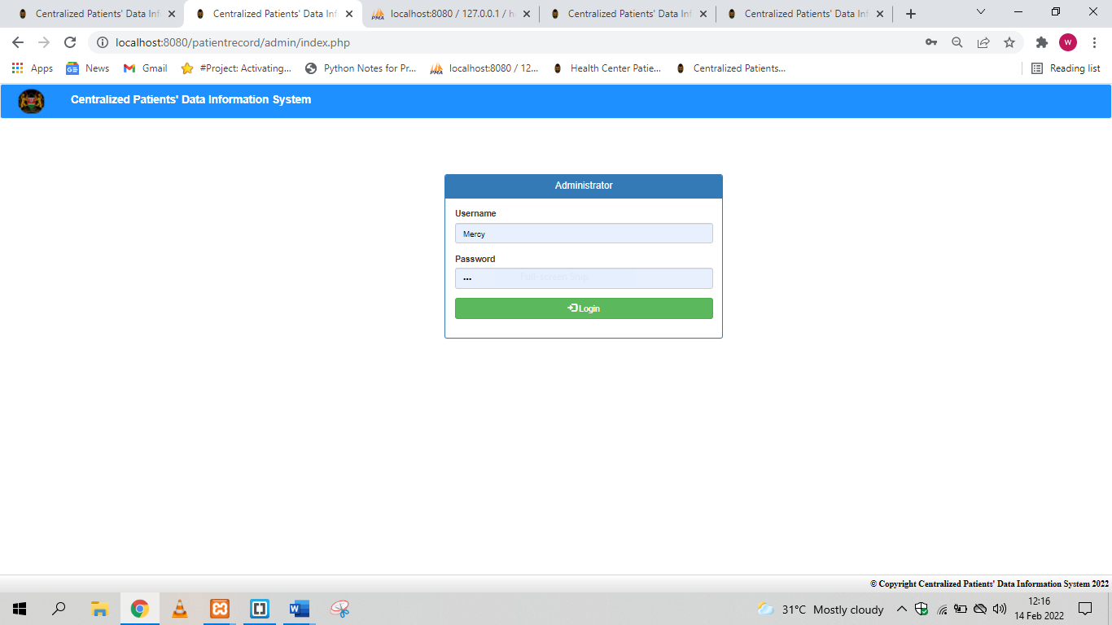

image 7 **Log in page**

allows user and admin to log in to the system

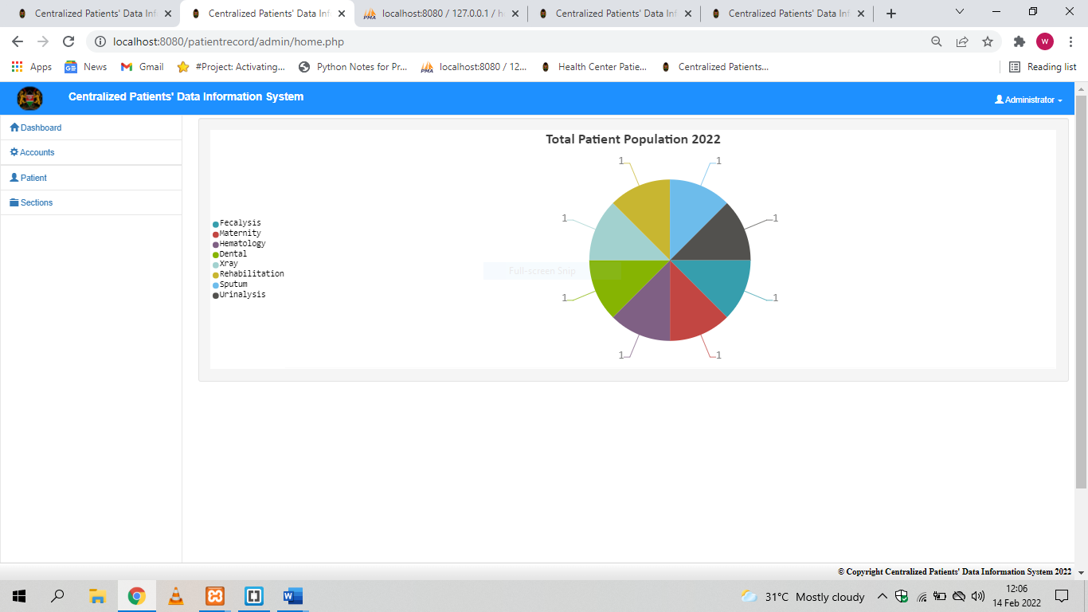

image 8 **The Dashboard:**

Allows viewing of general graphical data and contains the dashboard

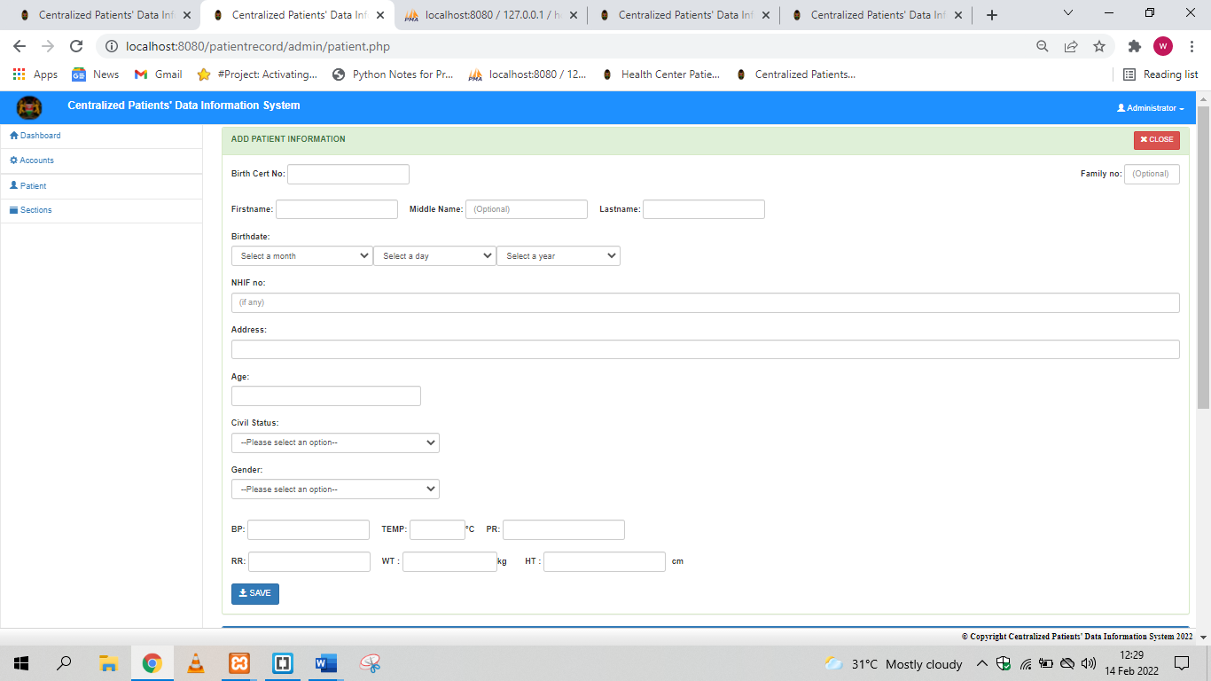

image 9 **Patient form:**

allows addition of new patients

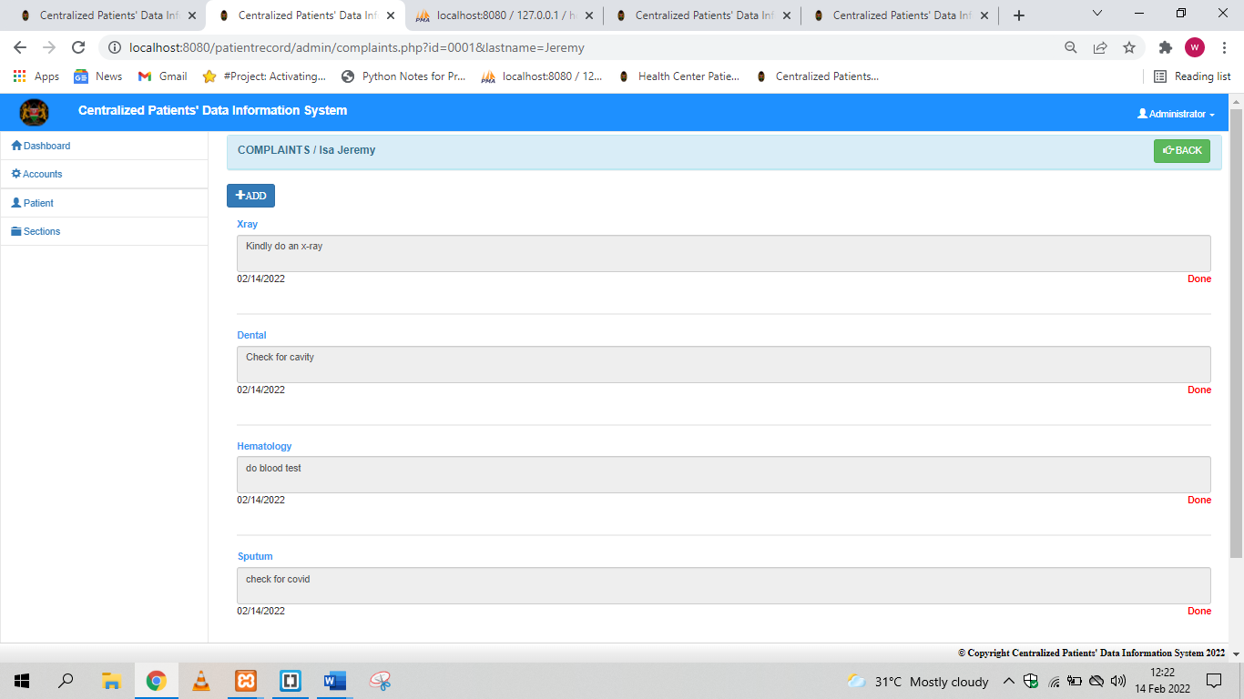

image 10 Complaint form:

### allows user to record patients complaints



image 11 **Sections dropdown:**

allows access to specific departments

## Internal manual

This shows the main function of the admin and is specifically for use by the administrators.

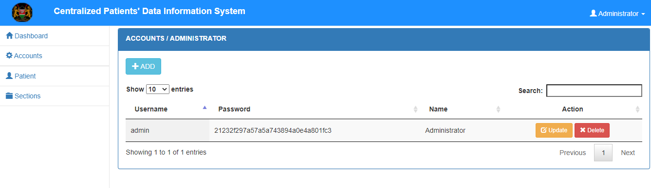

image 12 Adding and deleting administrators

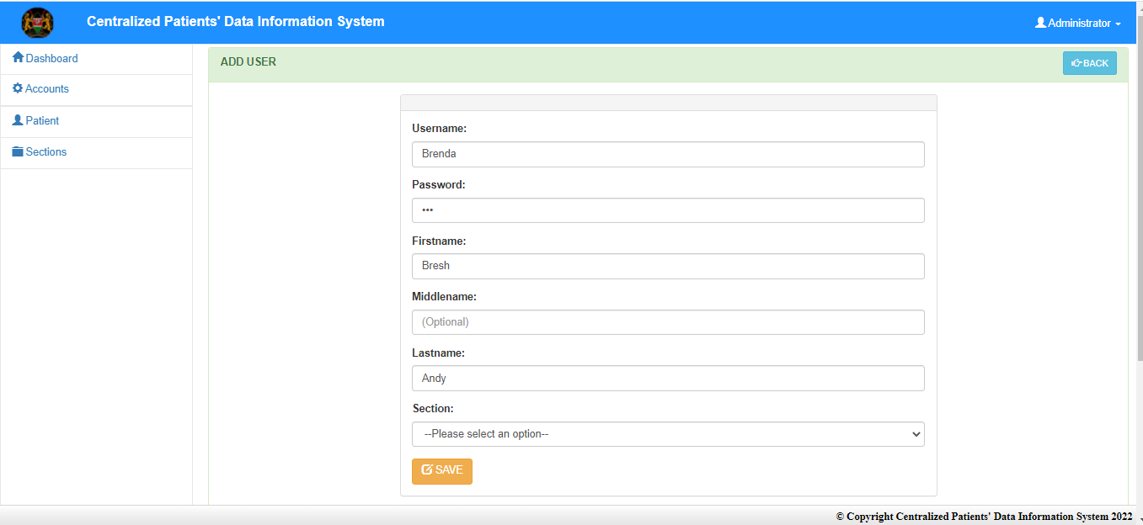

image 13 Adding new users and granting sectional access

### Reports

reports are document that present information in an organized format for a specific audience and purpose. Although summaries of reports may be delivered orally, complete reports are almost always in the form of written documents and graphical displays

### Graphical reports from departments

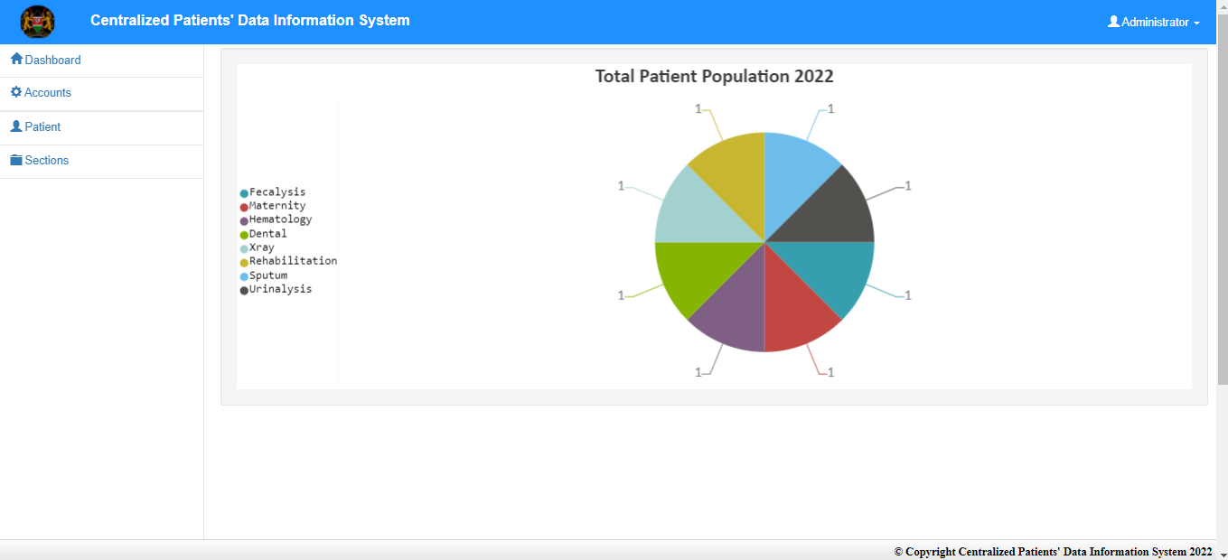

image 14 General graphical report

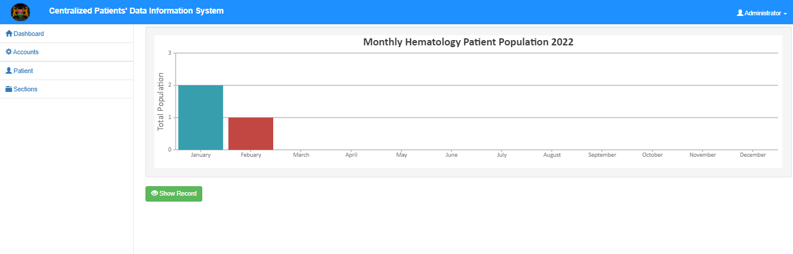

image 15 Blood test reports

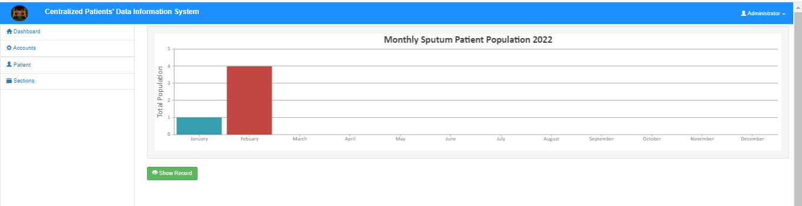

image 16 Sputum tests reports

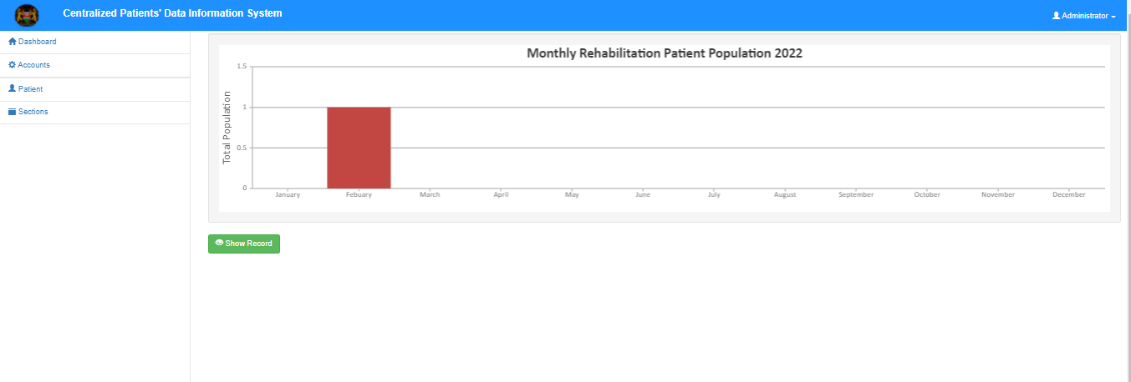

image 17 Rehabilitation reports

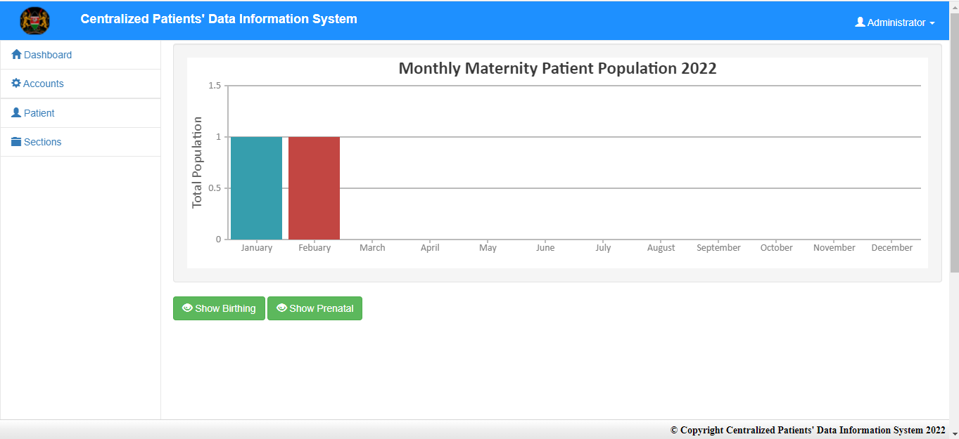

image 18 Maternity patients report

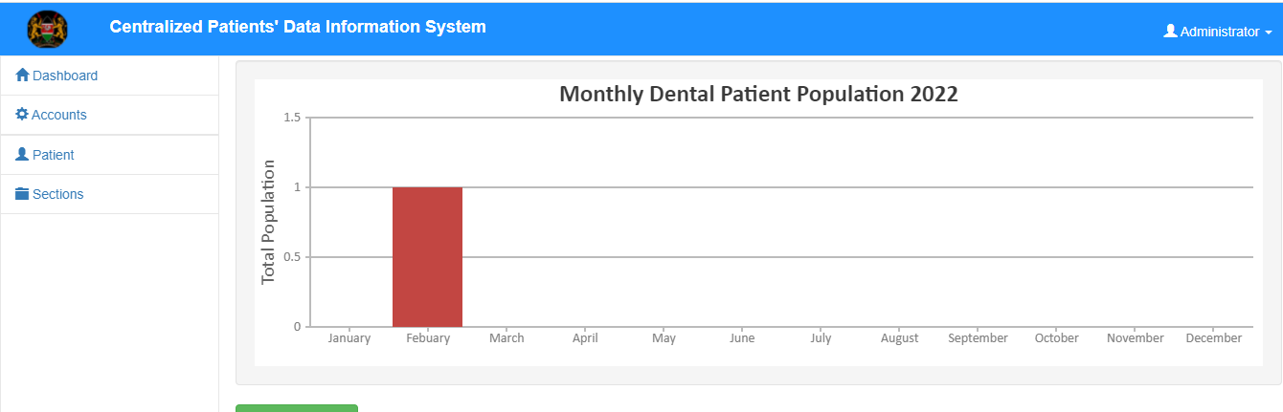

image 19 Dental patients report

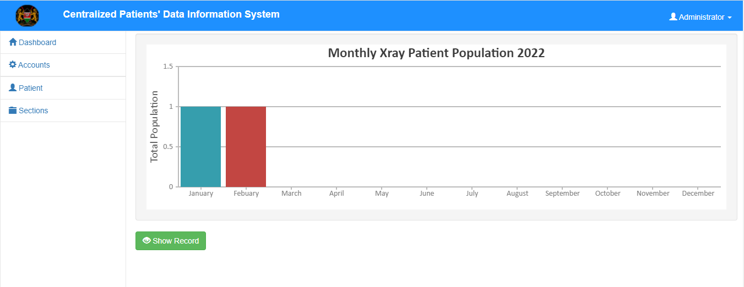

image 20 Xray population reports

## Sample questionnaire

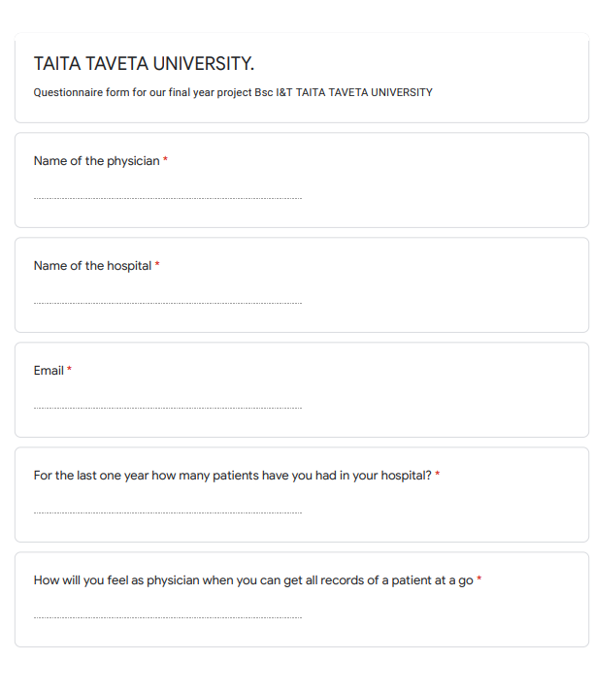

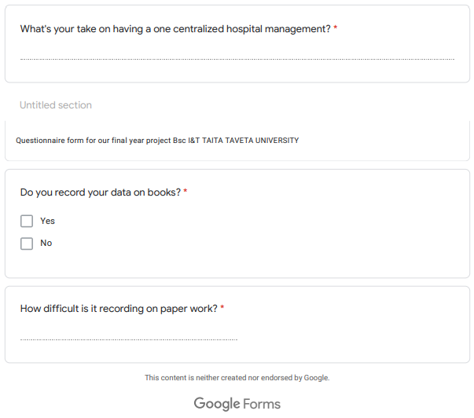

## References

1 Vision 2030, “Towards 2030.” Available at https://vision2030.go.ke. Accessed April 30, 2020

2. Fraser HS, Biondich P, Moodley D, Choi S, Mamlin BW, Szolovits P. Implementing electronic medical record systems in developing countries. Informatics in Primary Care; 2005. 13(2): p. 83-95. PMID: 15992493

3. Fraser HSF, Blaya J. Implementing medical information systems in developing countries, what works and what doesn’t. AMIA Annual Symposium Proceedings. 2010. American Medical Informatics Association. ISBN:1942-597X PMID: 21346975

4. English M, Irimu G, Agweyu A, Gathara D, Oliwa J, Ayieko P, Were F, Paton C, Tunis S, Forrest CB. Building learning health systems to accelerate research and improve outcomes of clinical care in low- and middle-income countries. PLOS Medicine; 2016. 13(4): p. e1001991. doi: 10.1371/journal.pmed.1001991. PMID: 27070913

5. Friedman CP, Wong AK, Blumenthal D. Achieving a nationwide learning health system. Science Translational Medicine; 2010. 2(57): p. 57cm29-57cm29. doi: 10.1126/scitranslmed.3001456. PMID: 21068

6. Kenya Health Information Systems Interoperability Framework,Ministry of health(MOH)

7. the Organization Health Metrics Network, Framework and Standards for Country Health Information Systems, 2nd ed., 2012. Available at https://www.who.int/healthinfo/country_monitoring_evaluation/ who-hmn-framework-standards-chi.pdf. Accessed on May 26, 2020

8. Healthcare Information and Management Systems Society, “HIMSS 2020 Definition.” Available at https:// www.himss.org/what-interoperability. Accessed May 26, 2020